Harris and Lake Park
United Methodist Churches Newsletter
Please consider being an
Usher/Greeter sign up sheet located on table by fellowship hall
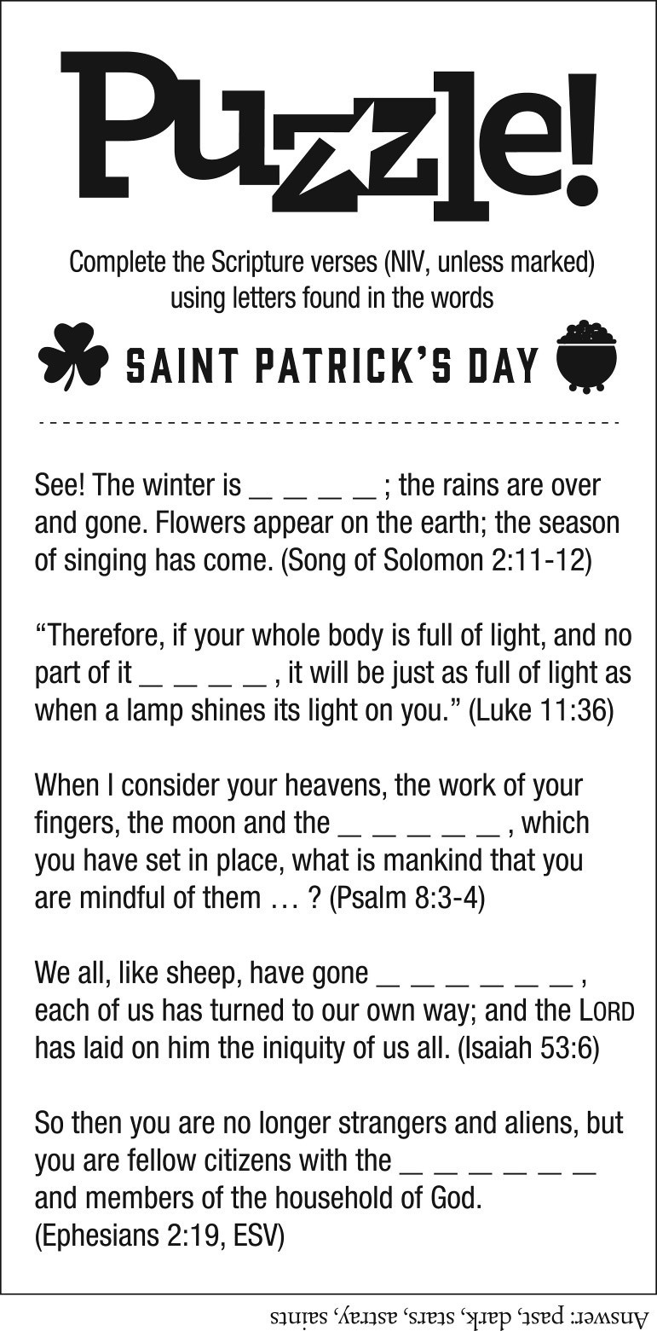
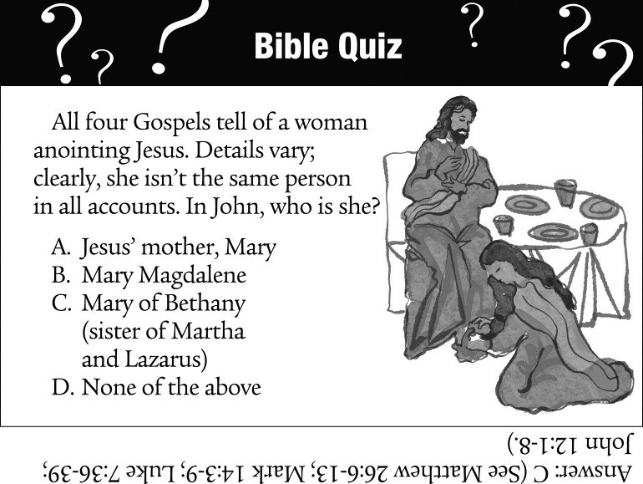
Harris & Lake Park UMC
PO Box 446
Lake Park, IA 51347-0446
You can now give to LPUMC online, by text or directly out of your account.

ONLINE GIVING: Go to the church website at www.harrislakeparkumc.org and click the “Give Now” tab and follow the instructions.

TO GIVE BY TEXT: enter 73256 to receive a response with your next steps

GIVE DIRECTLY FROM YOUR BANK ACCOUNT: automated clearing house (ACH); stop by the Savings Bank in Lake Park and they will be happy to help.
Non Profit Org.
U.S. Postage
PAID
Lake Park, IA 51347
Permit No. 6
Worship in the Parking Lot

Come join us for worship,
in the safety of your own car.

Tune your radio to 87.9 FM

Harris & Lake Park

United Methodist

Churches

We welcome you to grow together with us in Christ through
prayer and the Word.

March

2022

Harris UMC

208
N. Main

Harris, IA 51345

Worship 9:00AM

Sunday School 10:15AM

Custodian

Kelley Morgan

(702) 526
-
1054

Pastor Emmanuel T. Naweji

revnaweji@gmail.com

(
712) 832
-
3361

Lake Park UMC

th Ave
1471 135

Lake Park, IA 51347

Sunday School 9:15AM

Worship 10:30AM

Custodian

Mary Schmidt

(712) 331
-
1455

Church Office Manager

Amanda Money

M,W,Th,F

am
8:30
-
1:30
pm

Phone: (712) 832
-
3361

Email:
hlpumc@gmail.com

Webpage

harrislakeparkumc.org

Facebook Page

HLPUMC

YouTube Channel

Harris and Lake Park United
Methodist Church

Radio

87.9

Concerns, joys or prayer request

to be listed in the bulletin or monthly newsletter
can be sent to

the church email

hlpumc@gmail.com

or call the office at (712) 832
-
3361.

REMINDER:

Please help us keep our records up to date!

Let us know if you have a new

address or any other information we may need.

Your feedback is important to us!

Thank you!

HAVE YOU TRIED RIGHTNOW MEDIA?
RightNow Media gives you access to an online library of more than 20,000 biblically based videos for small groups, families, students, leadership
development, and children’s shows that you can stream instantly any time on any streaming device, mobile phone, or tablet. Create custom channels that
feature the contact you want front and center. In addition to videos, most studies include free downloadable leader’s guides and participant resources. Enjoy over
2,000 episodes for kids in the RightNow media Kids’ Library. To sum it up, it’s like the Netflix® of Bible study videos. You have access to video resources to help
you with parenting, marriage, discipleship, and so much more, with content for all ages and stages of life.
Choose any of the following ways to connect:
Download the RightNow Media App on any mobile device or tablet.
Follow the RighNow Media link on the Resources page of the Harris & Lake Park United Methodist Church Website.
Or you can text code :Rightnow UMCLP to 41411

1-Jordan Heikens  1-Conner Read  1-Vivian Worrick  2-Leah Bullard  2-Neil Niswander  3-Zoey Zevenbergen  4-Don Schroeder  4-Nate Johnson  4-Brent Jacobsen  5-Jeremy Updike  5-Randy Rowe  5-Calvin Nebelsick  5-Layne Jacobsma  6-Fred Hellinga  6-Lexi Stahly  6-Makenna Tigges  7-Stacey Ahrenstorff  7-Kade Heikens  8-Nick Elser  8-Tamie Morphew  8-Jared Herbert  8-Jess Bradley  8-Joshua Benson  10-Jane Crist  12-Gary Johnson | 12-Chad Matthiesen  12-Jacie Reuter  12-Elizabeth Schroeder  12-Joel Wiese  13-Mike Betz  13-Mike Taylor  13-Emly Naweji  14-Scott Robertson  16-Krew Rowe  16-Karl Watkins  17-Chanelle Gembler  17-Jolene Ehlers  17-Kelly Luitjens  17-Kevin Winters  18-Scott Gillespie  18-Nathan Shipman  18-Rose Robertson  19-Laura Heikens  20-Kay Lemker  21-Mel Zevenbergen  21-Bridget Raveling  22-Shirley Johnson  22-Gracie Gunderson  22-Joe Hornick  22-Belka Naweji | 23-Wanda Garloff  23-Carol Bonnema  23-Koltyn Bradley  24-Patrice Meyerdirk  24-Jacob Money  25-Terry Morrow  25-Tom Jansen  26-Troy Vande Hoef  26-Bob Crist  26-Lyla Akkerman  27-Roxie Leuders  27-Emma Niswander  27-Zella Ingham  27-Lindsey Packebush  27-Anna Lenderts  27-Katie Serck  28-Lara Tegtmeier  28-Tricia Reuter  29-Craig Krummen  29-McKenzie Heikens  30-Justin Zevenbergen  30-Britleigh Ingwersen  30-Tom Ransom

Meet Amanda Money

Our new Church Office Manager

Amanda moved to Lake Park with her family in October 2013 and quickly fell in love with the area and community. Amanda and her husband Jake have three boys; Jacob- a junior, Michael- a freshman, and Rager who is in kindergarten. Amanda and her family became members of The United Methodist Church of
Lake Park soon after moving to the area. She has served in various church committees over the years as well as teaching Sunday School. Amanda is active
in our community as a current member of The Lake Park Fire Department, has
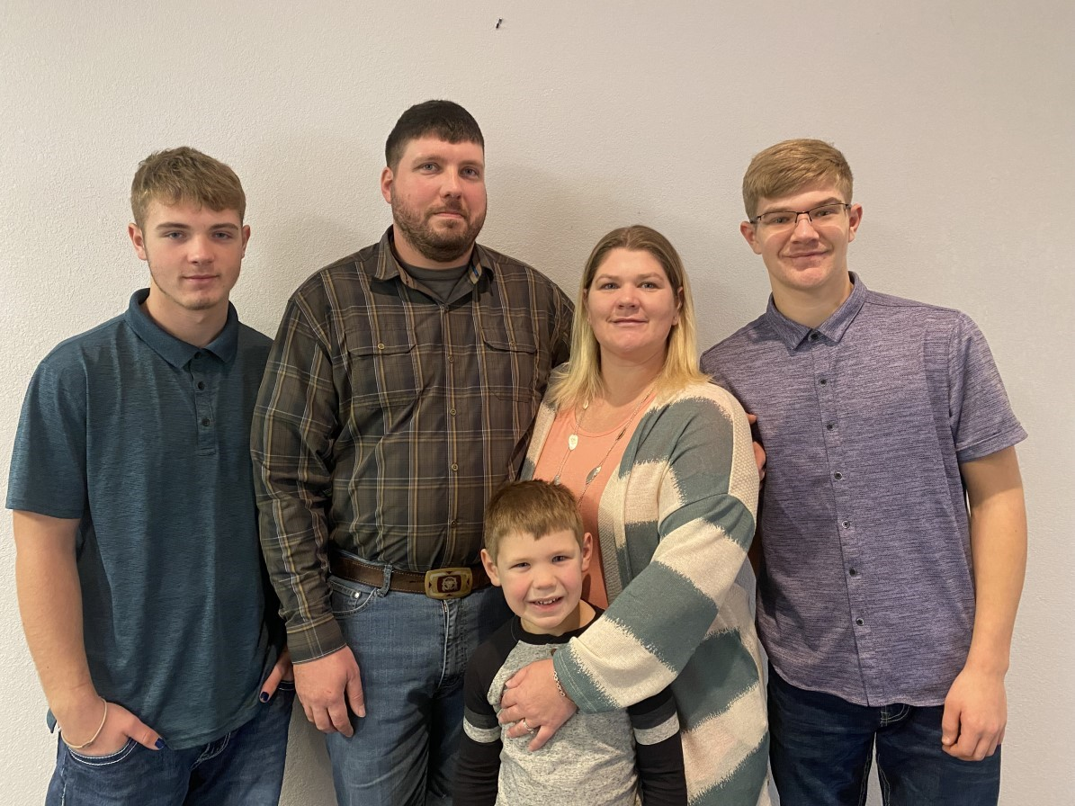
previously served as Den Leader, Popcorn Kernel, and Cub Master for The Lake Park Cub Scouts, as well as serving on the Board of Directors for Discovery House in Spirit Lake. In her spare time, Amanda enjoys time with her family, traveling, reading,

7
-
Lucien & Nicole Vabre

13
-
Jon & Laura Martin

14
-
Tom & Tracy Bosma

16
-
Tom & Patricia Weltzin

25
-
Bill & Shelly Boles

28
-
Tim & Roxie Lueders

crocheting, and motorcycle riding.
Feel free to stop into the church office to meet Amanda and say ‘Hello”.
Office hours will be Monday,
Wednesday, Thursday and Friday’s from 8:30am to 1:30pm.

Find your opportunity to serve
The Lord
Harris Coffee Schedule for March  6 - Cal Harms  13 - Mark Dillehay  20 - Shannon Serck  27 –Keith Klassen  March Ushers/greeters for Harris:  Harry Riesberg  Keith Klassen Noel Phillips | Serving as ushers/greeters in Lake Park  March 6 Jake & Amanda Money  March 13 Ushers/Greeters Needed March 20 Dave & Jerilyn Marra  March 27 Ushers/Greeters Needed Thank you for choosing to serve.  Upcoming opportunities to serve:  4/3; 4/10; 4/17; 4/24  Please take advantage of this opportunity by signing up on the sheet located on the table by the fellowship hall.  Thank you!
Lake Park Food Bank
The Lake Park food Bank is held the first Thursday of every month in the parking lot of the 1st Presbyterian Church.

Food boxes come from the Feeding America program from Des Moines.
The Lake Park Food bank also take donations to supplement and monetary donations to pur-
chase bread and other staples locally to add to
the boxes we receive. Approximately 70 families
&/or households are receiving food every month. We are in need of a few volunteers that could help with unloading the truck at about 1:00 PM and distribution at about 4:30 PM.
Please talk to Jerilyn Marra (712-348-0475) or Jim Kessler (712-330-1738) for more information.

Lake Park Volunteers for March
Sunday School Snacks

March 6 Marie Mattiesen
March 13 Snack provider needed
March 20 Snack provider needed
March 27 Snack provider needed

Please sing up to provide snacks for future dates on the sheet in the narthex. Thank you!

Lake Park Volunteers for March
Sunday School Snack Servers

March 6 Snack server needed
March 13 Snack server needed
March 20 Snack server needed
March 27 Snack server needed

Please sign up to serve snacks for future dates on the sign up sheet in the narthex. Thank you!

Hello, March 2022:

I recently read an article online titled “6 Benefits of Reading Fiction That Will Help Your Child Succeed.” I know what you are thinking. “I’m not a child. This doesn’t apply to me.” Let me remind you that you are a lifelong learner. Lifelong learners are readers. So, yes, this article applies to all of us. I have taken the liberty of paraphrasing the list. Look at it, and I think you will agree that reading a fiction book or two this month is a celebration in growing. 1) Reading fiction helps us to interpret and infer. 2) Reading fiction aids
creativity. 3) Reading fiction makes us more empathetic. 4) All reading builds vocabulary. 5) Reading fiction can help us contemplate and reflect. 6) Reading fiction helps us to remember to focus.
Deb Morrow, Church
Librarian

If you want to get caught up in rural Minnesota (ie Worthing- “Acts of Faith is master storyton, Round Lake) when teach- teller Erich Segal’s most moving ers boarded with the families of and ambitious work to date: a pupils, water was hauled and spellbinding story of three exheated for use in the house, traordinary people whose lives and socializing was second to are forever changed when sahard work then Lambs Danc- cred and secular worlds coling is the book for you. Minne- lide.”* (Located in Christian Ficsota author, Mary Johnson, re- tion.) minds us that stoic spirits, strength, determination and op- The library now has book numtimism were the common de- ber three of the Lancaster nominators of this distinct peri- County Secrets by Suzanne od and culture. (Located in Woods Fisher. “Beautifully writChristian Fiction.) ten, The Search is a skillfully woven story that takes you
Two women— “once lost to through unexpected twists and each other, are about to come turns on the long country road together in a time of both joy toward truth. Immerse yourself and sadness. Sisters by blood, in this heartwarming—and surstrangers by choice, each prising—tale of young love, forstands at a crossroads, afraid to giveness, and healing.”* confront the betrayals and (Located in Christian Fiction.) heartbreaks of the past. They will be reunited at last, drawn *Taken from book cover by tragedy into the darkest of times, and must figure out how to face their deepest fears together… or lose everything.”* Between Sisters by Kristin Hannah is located in the Christian Fiction section of the church library.

Lake Park UMC Attendance Offering Harris UMC Attendance Offering
“
I alone cannot change the world, but I can cast a
stone across the waters to create many ripples.
”

-
Mother Teresa

January 30 70 $1409.75 January 30 25 $1285.00
February 6 $3001.22 February 6 40 $835.00
February 13 $2329.50 February 13 27 $1435.00
February 20 February 20

Whatever you give is acceptable if you give it eagerly. And give according to what you have, not what you
don’t have. 2 Corinthians 8:12 (NLT)

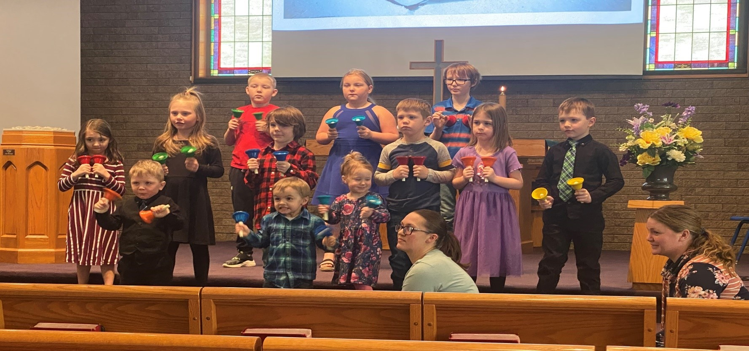
Elementary Bells
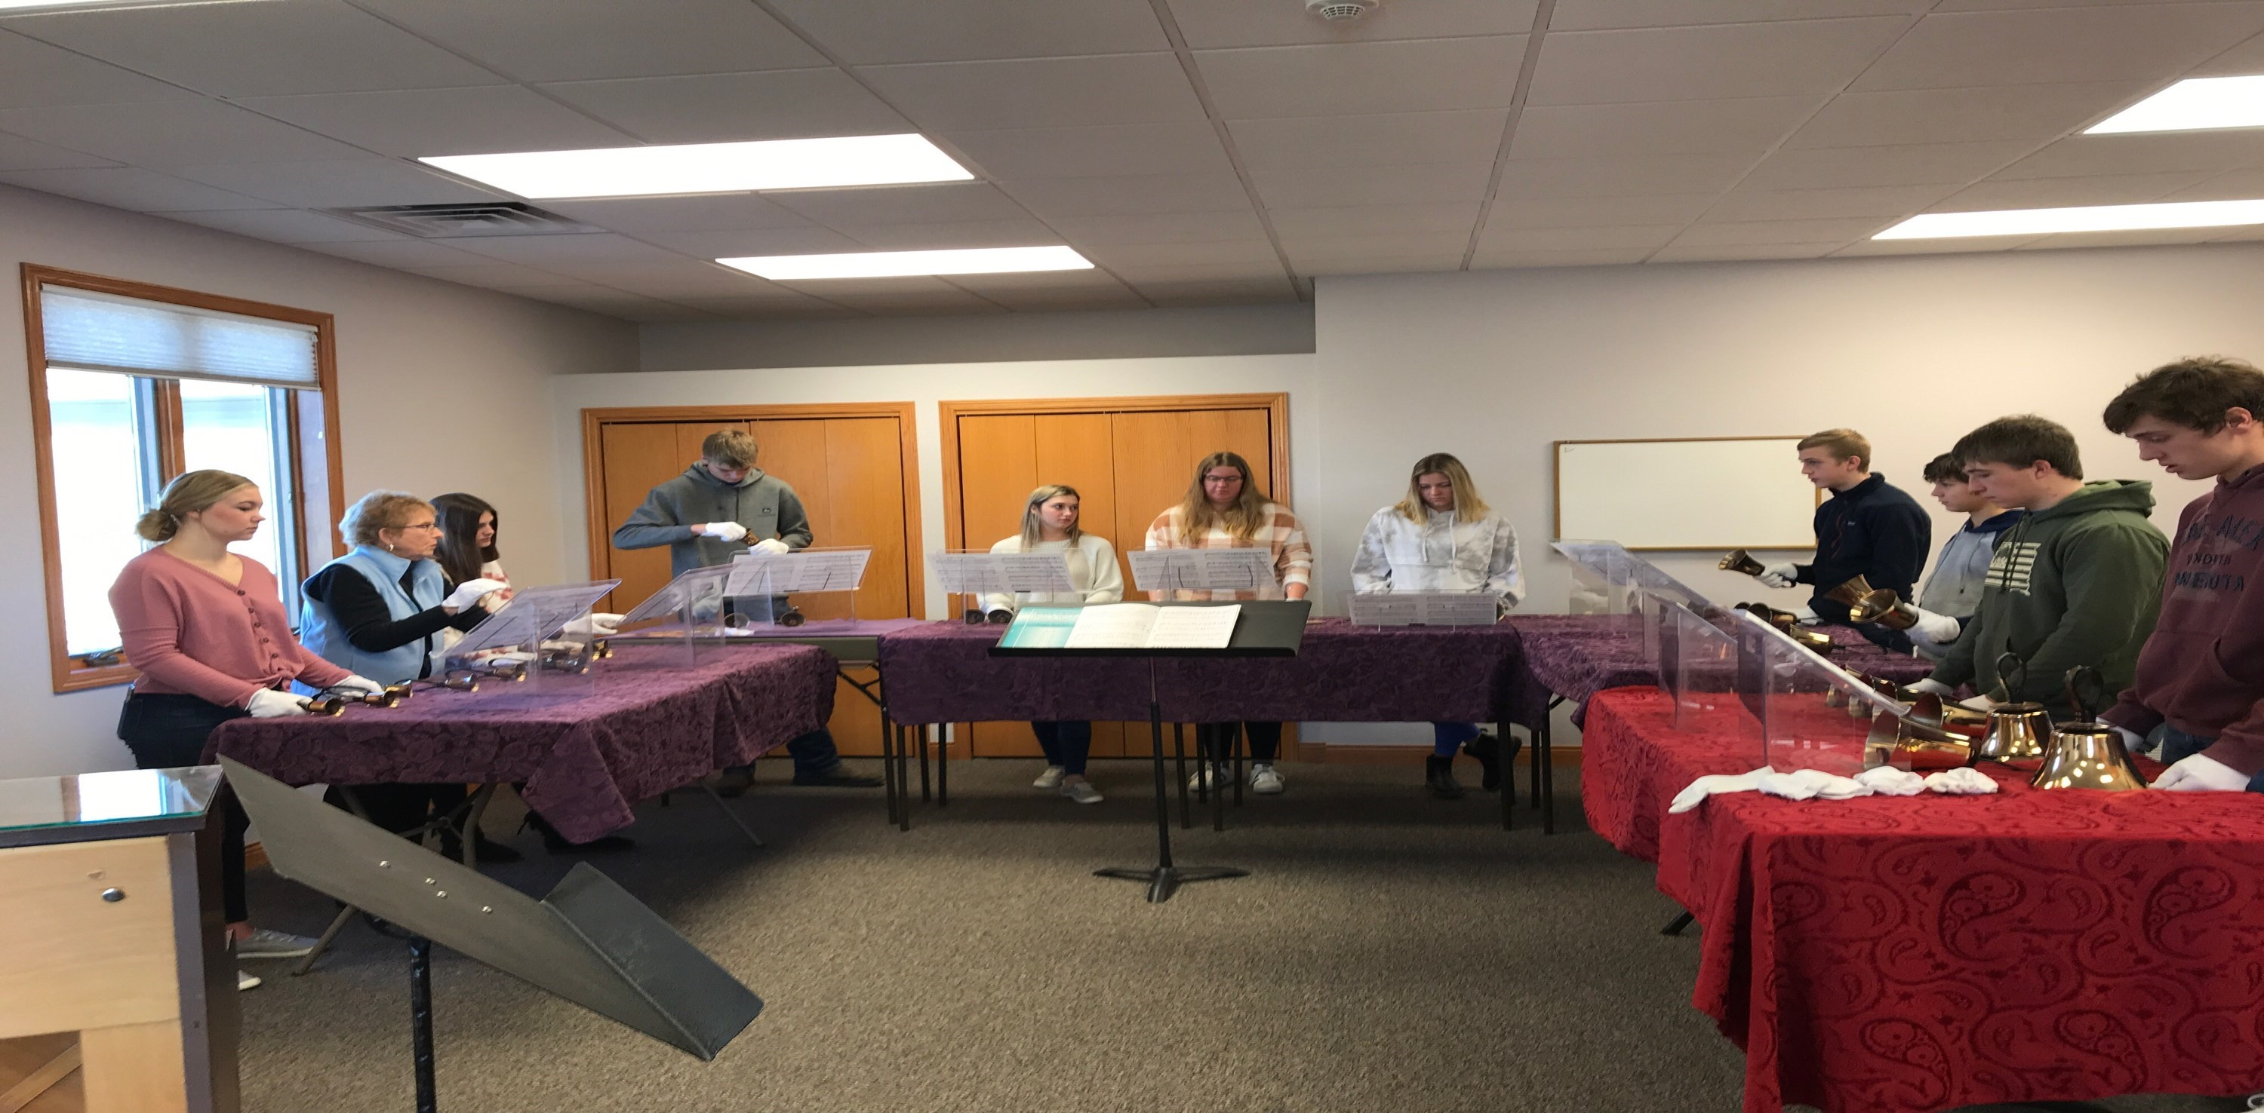
High School Bell Practice
Dear Church Family,

March always shows up on us quickly because the month of February is short. This time of the year also ushers us into a new church season, Lent, which begins on Ash Wednesday. This year, the Lenten season starts on March 2nd.

As you may have seen it already, we will have a community Ash Wednesday service at the Presbyterian Church in Lake Park at 6 p.m.
Following that service, I will lead another Ash Wednesday service only for the Youth groups and their leaders at the Lake Park United Methodist Church at 7 p.m.

Why Lent and what significance does it have for us in the 21st century?

To better understand Lent, we have to start with what Ash Wednesday is all about. This service draws its origin with the practice of using ashes and dust as a way to remind us of our brokenness, sinfulness, and mortality (and humanity). It traces back first to Genesis 3:19 when God reminded both Adam and Eve, after they disobeyed God, saying: “For dust you are and to dust you shall return.”

Later on, the use of ashes and dust then became such a part of the Jewish tradition representing the state of being where one is seeking forgiveness and displaying an attitude of repentance. You come across stories in the Bible with people such as Job, David, and the others, sitting in dust and putting ashes on themselves to show they are grieving due to sin or mortality.

Many centuries later, and after the Church had already born and established as the Roman Catholic Church, Christians, in Rome, started using Ash Wednesday for penitents and grievous sinners as the first day of Lent in preparation to receive the sacrament of the Eucharist (communion).

Lent then would end during the six week, and which gives it a total number of days of 42, in length, before Easter. If you exclude Sundays, you are left with 36 days of penitence (primarily fasting) until the day of the Lord’s Resurrection. In the 7th century, the Church added 4 days before the first Sunday in Lent in order to have 40 fasting days, which are the number of days Jesus spent fasting in the desert (40 days).

The invitation, today, and through this note, which will make Lent more significant this year, is first to attend our Ash Wednesday service (March 2 at 6 p.m. - Presbyterian Church, Lake Park). Then, you will have to decide how you want to prepare for the celebration of the Lord’s Resurrection (Easter) this year.

There are many ways you could do it. Here are just a few I can think of suggesting to you right now:
- Set time aside daily to pray for those whose names are on our prayer list.
- Pray for every person serving on our different Church teams and committees. If you want their names, call the office and Amanda will happily give you the names.
- Pray for our Church families. You can use the Church directories and take sometime every day to pray for one family at a time.
- Pray for Harris and Lake Park. For this, you can do a prayer drive. Every day drive by a home or two, and pray for these two homes while sitting in your car. • Pray for God to draw more people to the Church.
- Ask God to show us how else to pray during Lent this year.

Above are just a few ways you can make Lent more meaningful this year by praying for your neighbor. Our sermon series this Lent, “God has called you to more,” will also help us as a tool to recenter more on Christ and what God has already invested in each one of us through faith in Christ.

This year’s Lent is going to be very special for us all and I cannot wait to hear stories of how God will show up in your life throughout this season in preparation of the Lord’s death and resurrection.

See you in worship,

Pastor Emmanuel.

PRAYER CONCERNS
Donald Mumm and family, Daxton De Groot (great grandson of
Ginny Verdoorn), Rhonda Miller, Rick Wilson & his family, Jan
Atwell (sister of Steve Krummen & Arlene Jaycox), Ellen Wolfe,
Rod Graham, family of Bob Ahrenstorff, Allen & Loretta Rowe,
Amanda Bondhus, Richard Friedrich (brother-in–law of Jan
Adult Bell Choir Practice  Wednesday March 9 at 6:30pm |  | United Methodist Women  Meet the first  Wednesday of March at 1:00 pm
It’s that time of year again for us to take our turn as Christians to serve our community. Our church has been scheduled for the month of March to deliver food from Wal-Mart to the Upper
Des Moines office in Spirit Lake. We are to pick up at 9am
Monday, Tuesday, Wednesday each week for the month of March. Please contact Judy Siemers at (712)330-6552 to schedule a time to assist with this great opportunity.
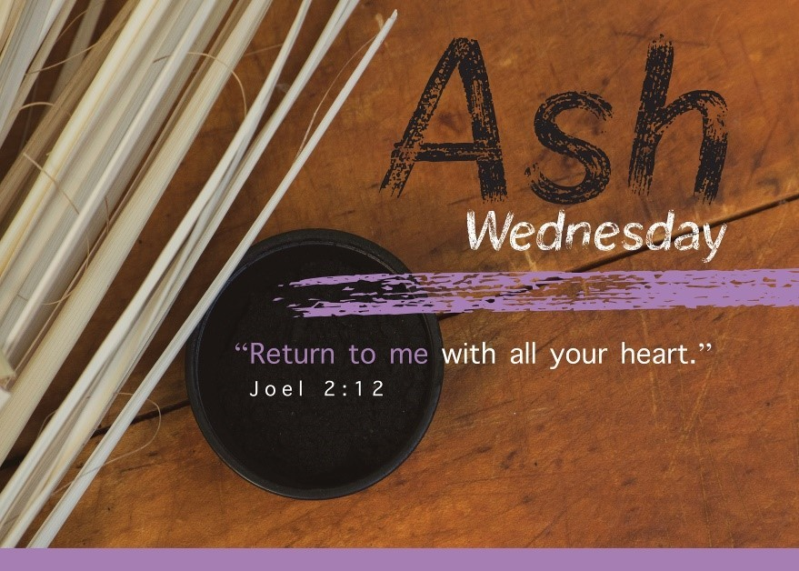
Mitchell), Craig Heuer (father of Kayla Updike),
Service March 2 at 6pm

Presbyterian Church

Jr. & Sr. High

Youth Group

Service to follow at 7pm

United Methodist Church

Claire Yaw (niece of Marie Mattiesen), Pastor Emmanuel and Rosa, Our Church Family,
District Superintendent Ron Carlson and Bishop Laurie.

A Prayer for Lent
This year, Ash Wednesday, the first day of Lent, falls on March 2. During worship services that day, pastors in many Christian churches dip a finger in ashes (often made by burning branches from the previous Palm Sunday) and make a cross on parishioners’ foreheads.
Why ashes? Traditionally, they’re a sign of mourning, humiliation and penitence. Ashes also represent the frailty and temporary nature of human life
(“Your are dust, and to dust you shall return,” Genesis 3:19). Christians are
pained because our sins led to Jesus’ death. _{For where your}
Immanuel Lutheran Church, Spirit Lake

With repentant hearts, resurrection on Easter Sunday.

For Ash Wednesday—and throughout the 40 days of Lent—ponder this prayer from an Italian sacramentary, or liturgical book: “O God, you know how fragile is our human nature, wounded as it is by sin. Help your people to enter upon the Lenten journey strengthened by the power of your word, so that we may be victorious over the seduction of the Evil One and reach the paschal feast in the joy of the Holy Spirit.”
treasure is, there your heart will be
also
Matthew
6:21

Sunday |  | Monday |  | Tuesday | Wednesday | Thursday | Friday |  | Saturday
* times and dates are subject to change |  |  | 1 |  | 2  ASH WEDNESDAY  6:30am Men’s Bible Study  1:00pm UMW  6pm Ash Service @ Pres. Church  6:30pm Jr./Sr. High Youth  Groups –Ash Services at 7pm | 3  Community Food Bank  7:15pm Women of Joy Circle | 4 | 5
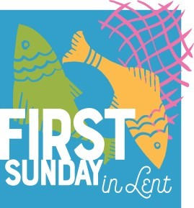  6  5:30pm Grandparents Bible Study | 7 |  | 8 |  | 9  6:30am Men’s Bible Study  6:30pm Adult Bell Choir Practice  7:00pm Lake Park AD Council | 10  7:00pm Harris AD Council | 11 | 12
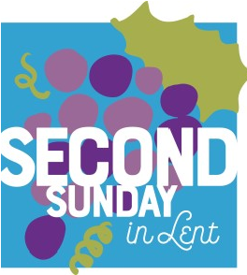  13  5:30pm Grandparents Bible Study | 14 |  | 15 |  | 16  6:30am Men’s Bible Study  6:30pm Jr. /Sr. High  Youth Groups | 17 | 18 | 19
20  First Day of Spring  5:30pm Grandparents Bible Study | 21 |  | 22 |  | 23  6:30am Men’s Bible Study | 24 | 25 | 26
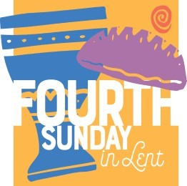  27  2:30pm Worship at  the Lake Park Care Center  5:30pm Grandparents Bible Study | 28 |  | 29 |  | 30  6:30am Men’s Bible Study  6:30pm  Education Committee Meeting | 31

